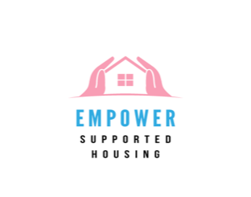
Empower Supported Housing
Self-Administration of Medicines (SAM) Assessment Form

Instructions
This form is to be completed by the referring agency for potential residents who are currently prescribed medication for any health-related conditions (mental or physical). If the resident is not on any medication, this form does not need to be completed.
Please inform the resident that Empower Supported Housing does not administer medication. It is the resident’s responsibility to manage their own medicines. This will be further discussed with the resident during the interview stage.

Resident Information
Resident Name | Date of Birth | Assessment Date

Self-Administration Responsibility
Empower Supported Housing enables residents to manage their own medication safely. You are required to:
- Keep your medication in a secure location.
- Take your medication as prescribed by your healthcare provider.
- Inform staff of any changes to your medication or dosage.
- Contact your GP or visit A&E if you experience any side effects or have concerns about your medication.

Medication Information
Please list the resident’s current medications, including dosage and reason for taking them:
Medication Name | Dosage | Reason for Taking

Assessment Questions
Please complete the following questions based on the resident’s ability to self-administer medication:
Question | Yes | No | Comments/Details
Has the medication been prescribed by a GP?
Is the resident currently managing their own medication?
Is the resident physically and mentally capable of self-administration (e.g., opening containers)?
Can the resident read and understand medication labels?
Does the resident know what each medicine is for?
Does the resident know the correct dosage for each medication?
Does the resident know how to take their medication (e.g., with food, at specific times)?
Does the resident understand what to do if they run out of medication?
Does the resident know how to seek help if there is a problem with the medication?

Medication Safety Guidelines
- Never exceed the prescribed dosage or change your medication without consulting your doctor.
- Do not share your medication with others.
- Inform staff if you change medications or adjust your dosage.
- Keep your medication out of reach of children and store it safely.

Resident Consent to Self-Administer Medication
By signing this form, you acknowledge that:
- You have been informed about self-administration of medicines at Empower SH
- You understand that the responsibility for taking and managing your medication lies with you.
- You agree to store your medicines safely and follow the prescribed dosage.
- You will inform staff if any changes to your medication occur.
- You understand the risks and responsibilities involved in managing your own medication.

Resident Name | Resident Signature | Date

Staff Confirmation
I confirm that the resident has been fully informed about self-administration of medication and has agreed to take responsibility for managing their medicines.
Staff Name | Staff Signature | Date

